Vulnerability Assessment of Test Network

Name: Mhetre Vaishnavi Vinayak
Internship: Cyber Security Internship
Date: 10/04/2026

Objective

The objective of this project is to perform a vulnerability assessment on a test network using security tools. The aim is to identify open ports, running services, and potential vulnerabilities, and to suggest appropriate mitigation techniques to improve system security.

Tools Used

- Kali Linux
- Metasploitable2
- Nmap
- Nikto
- Dirb



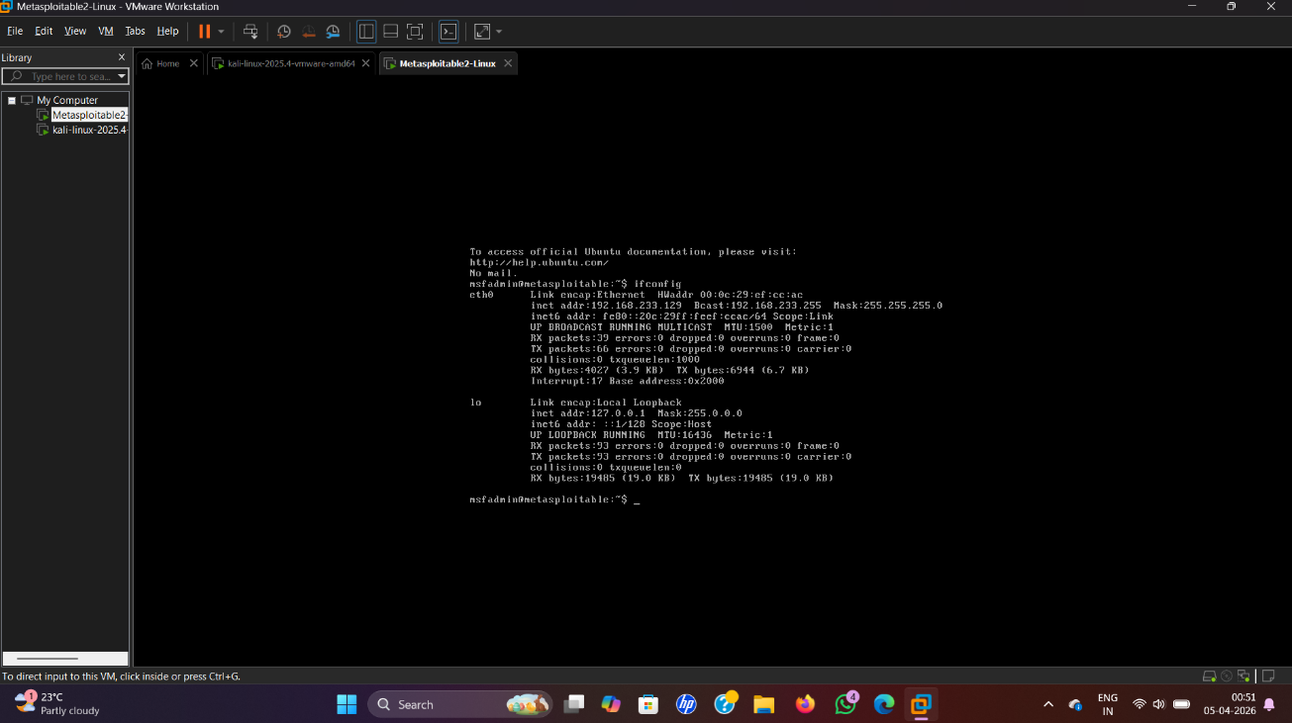

Lab Setup

A virtual lab environment was created using VirtualBox. Two virtual machines were configured:
- Attacker Machine: Kali Linux
- Target Machine: Metasploitable2
Both machines were connected using a Host-Only network to enable communication between them.

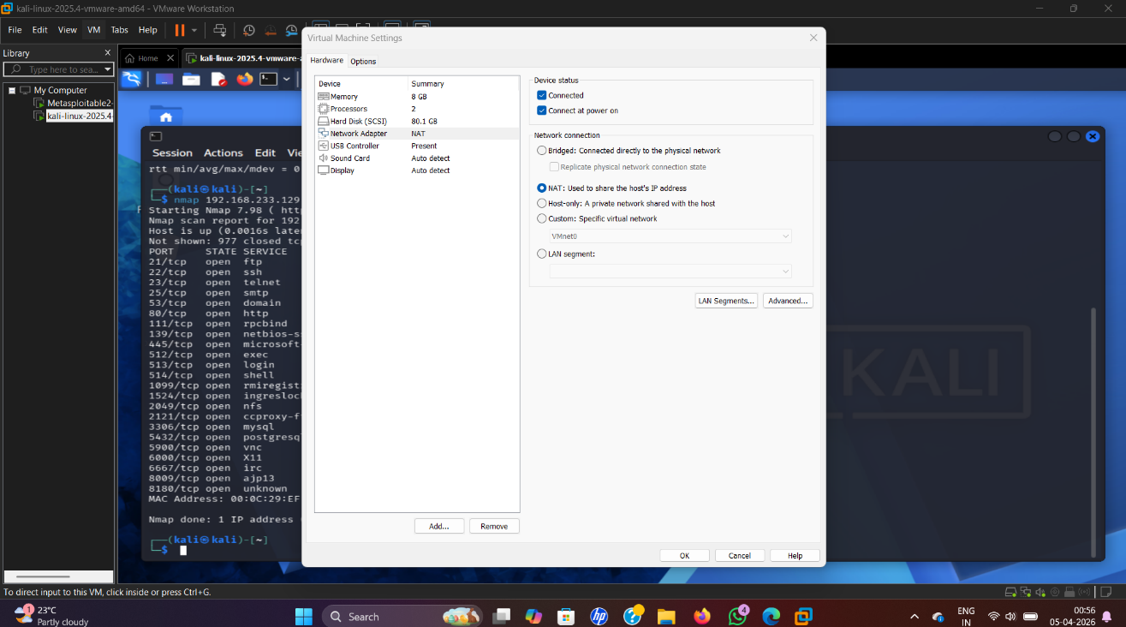

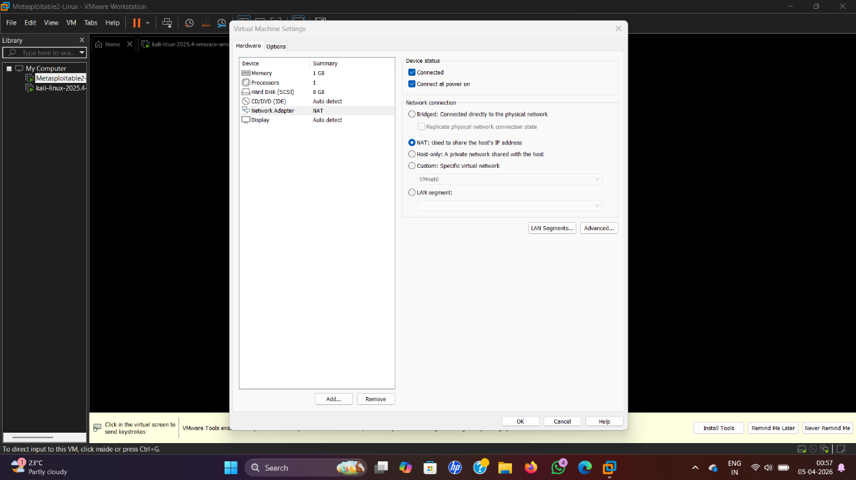

IP Address Identification

The IP address of the target machine (Metasploitable2) was identified using the following command: ifconfig
The connectivity between Kali Linux and the target machine was verified using the ping command: ping <target_ip>

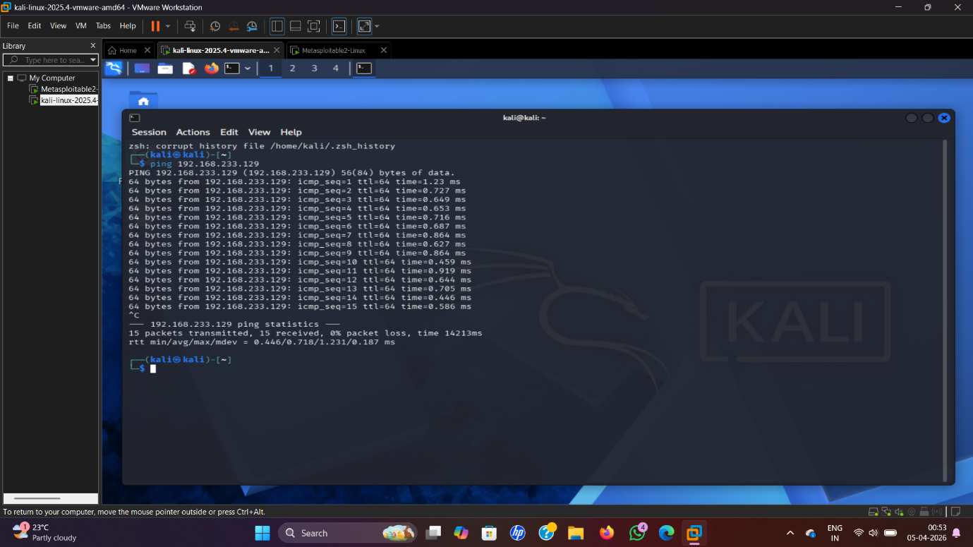

Network Scanning using Nmap

Nmap was used to scan the target system and identify open ports and services.
Command: nmap <target_ip>
Detailed Scan: nmap -sV -A <target_ip>
The scan revealed multiple open ports and services running on the target system.
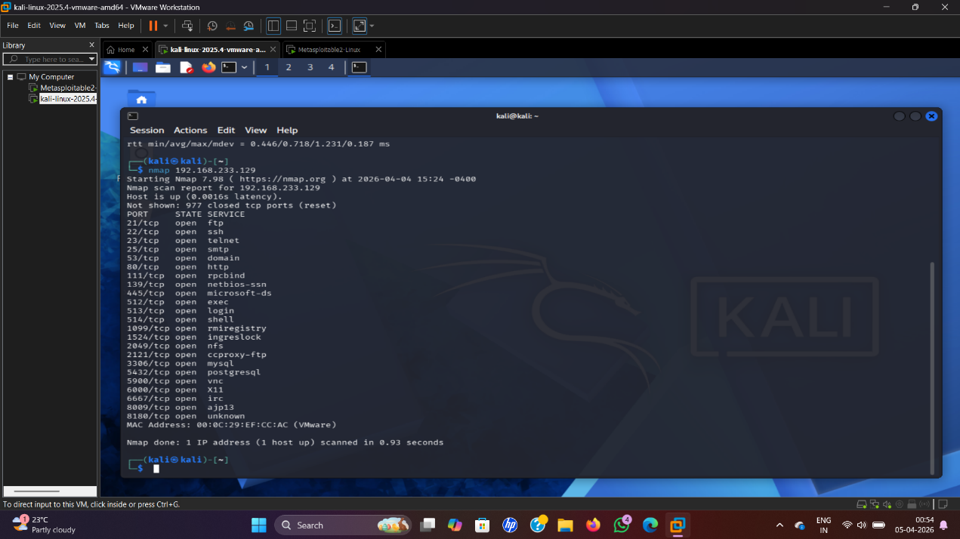
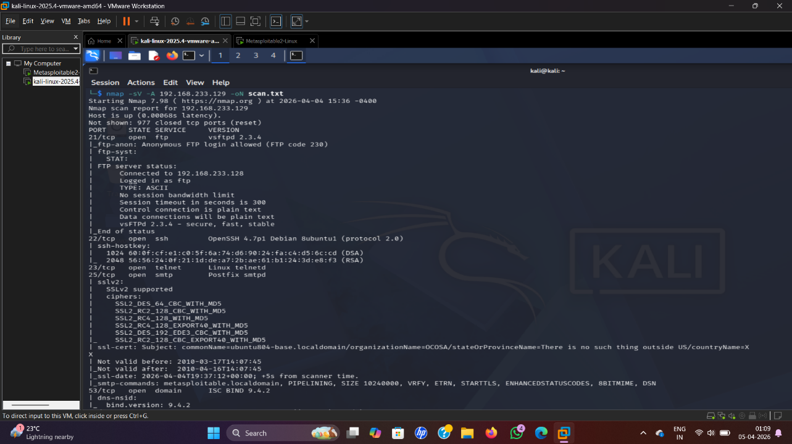

Vulnerability Identification
Based on the scan results, the following vulnerabilities were identified:
1 FTP Service (Port 21)
- FTP service is running and allows anonymous login.
- This can lead to unauthorized access to sensitive files.
2 Telnet Service (Port 23)
- Telnet transmits data in plain text.
- Attackers can easily capture login credentials.
3 HTTP Service (Port 80)
- Web server is outdated and may contain vulnerabilities.
- It can be exploited using web-based attacks.
4 SMB Service (Port 445)
- SMB service is vulnerable and can allow unauthorized file access.

Web Vulnerability Scanning (Nikto)
Nikto was used to scan the web server for vulnerabilities.
nikto -h http://<target_ip>
Findings:
- Missing security headers
- Server information disclosure

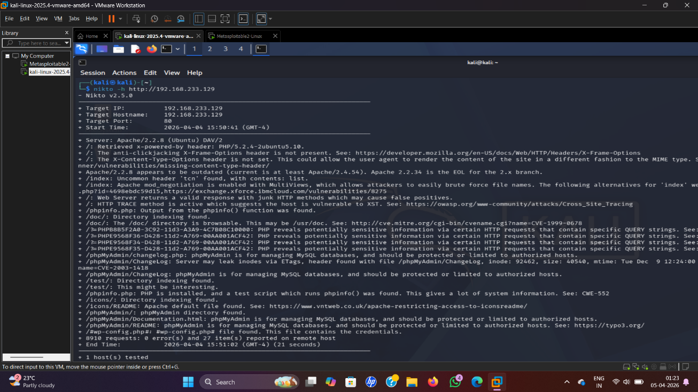

Directory Enumeration (Dirb)
Dirb was used to discover hidden directories on the web server.
dirb http://<target_ip>
Findings:
- Sensitive directories like /admin and /login were found

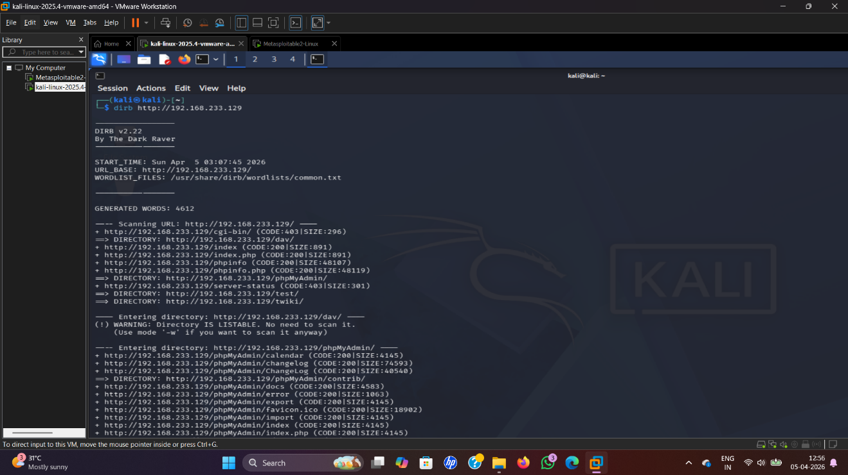

Mitigation Techniques
The following steps are recommended to secure the system:
FTP Mitigation
- Disable anonymous login
- Use secure FTP (SFTP)
- Apply strong authentication
Telnet Mitigation
- Disable Telnet service
- Use SSH instead
- Enable encryption
HTTP Mitigation
- Update web server
- Enable HTTPS
- Hide server information
SMB Mitigation
- Disable SMB if not required
- Apply latest patches
- Restrict access using firewall
Directory Protection
- Disable directory listing
- Restrict access to sensitive folders
- Remove unnecessary files
Summary Table :-
Port | Service | Vulnerability | Risk | Mitigation
21 | FTP | Anonymous login | Data leak | Disable
23 | Telnet | Plain text | Password theft | Use SSH
80 | HTTP | Outdated server | Web attacks | Enable HTTPS
445 | SMB | Weak config | Unauthorized access | Patch system

Conclusion
The vulnerability assessment of the test network revealed multiple security issues such as open ports, insecure services, and misconfigurations. These vulnerabilities can lead to serious risks including unauthorized access, data leakage, and system compromise.
By applying proper mitigation techniques such as disabling insecure services, updating software, and implementing security controls, the overall security of the system can be significantly improved.

